Final meeting for sprint 2 (Team 77)

## Meeting date | time Date | Time | Meeting location Location

## 24/10/18 4-6pm 2hrs S-block (S502)

|  |  |  |  |  |  |  |  |
| --- | --- | --- | --- | --- | --- | --- | --- |
| |  |  | | --- | --- | | Meeting called by | Keonwoo Lee | | Note taker | Keonwoo Lee | | Timekeeper | Keonwoo Lee | | Attendees  Keonwoo Lee, Dipper Dai, Yiming Pan, Anqi Cui  Non-Attendees  - |

Discussion Conversation

The purpose of having the meeting is to finalise the release 1 and check if ever team member is on the same page for the upcoming demonstration.

* **Every story in sprint 2 is completed**
* **Added more verifications in the “Sign up” page, such as Company staff’s unique ID No.**
* **The “Management System” menus are displayed even when the company’s logo is clicked by the user on any web page**

|  |  |  |
| --- | --- | --- |
| Action items | Person responsible | Deadline |
| **Topic 1** Preparation for the final release demonstration | Keonwoo Lee, Anqi Cui, Dipper Dai, Yimming pan | - 25/10/18 |
| **Topic 2** Upload every resource on to the git hub repository |  | -25/10/18 |
| **Topic 3** Complete peer review |  | -26/10/18 |
| **Topic 4** Complete individual portfolios |  | -26/10/18 |

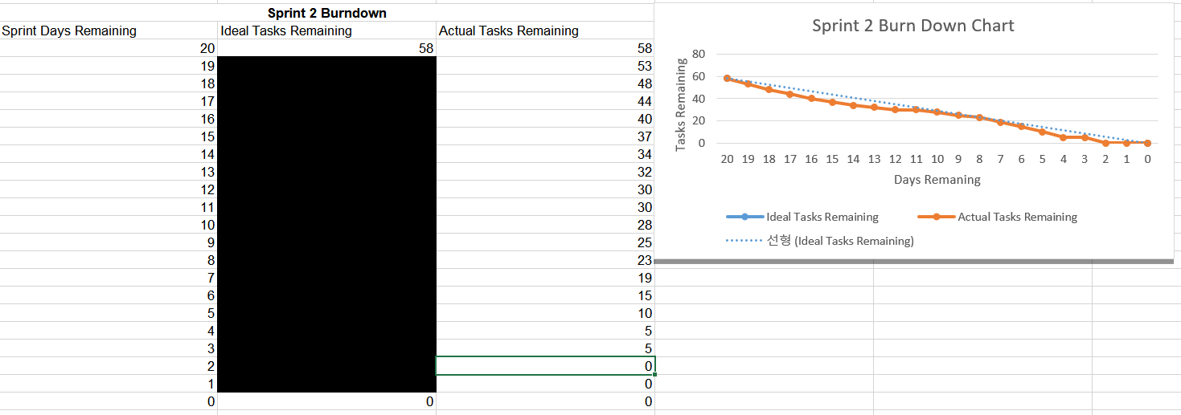**The final burndown chart**